Experiment 5:
Fourier Series Analysis of Periodic Signals
Objective 1: Fourier Series Representation of Continuous-Time Periodic Signals
CODE :
clc; clear; close all;
figure;
A = 1;
f0 = 1;
T = 1/f0;
t = linspace(0, 2*T, 2000);
% Half-wave rectified sinusoidal signal
x = A*sin(2*pi*f0*t);
x(x < 0) = 0;
N = 10;
a0 = (2/T)*trapz(t, x)/2;
an = zeros(1,N);
bn = zeros(1,N);
for k = 1:N
an(k) = (2/T)*trapz(t, x.*cos(2*pi*k*f0*t));
bn(k) = (2/T)*trapz(t, x.*sin(2*pi*k*f0*t));
end
xFS = a0*ones(size(t));
for k = 1:N
xFS = xFS + an(k)*cos(2*pi*k*f0*t) ...+ bn(k)*sin(2*pi*k*f0*t);end
plot(t,x,'k','LineWidth',1.2);
hold on;
plot(t,xFS,'r--','LineWidth',1.2);
grid on;
xlabel('Time (s)');
ylabel('Amplitude');
title('Fourier Series Representation of a Periodic Signal');
legend('Original Signal','Fourier Series Reconstruction');

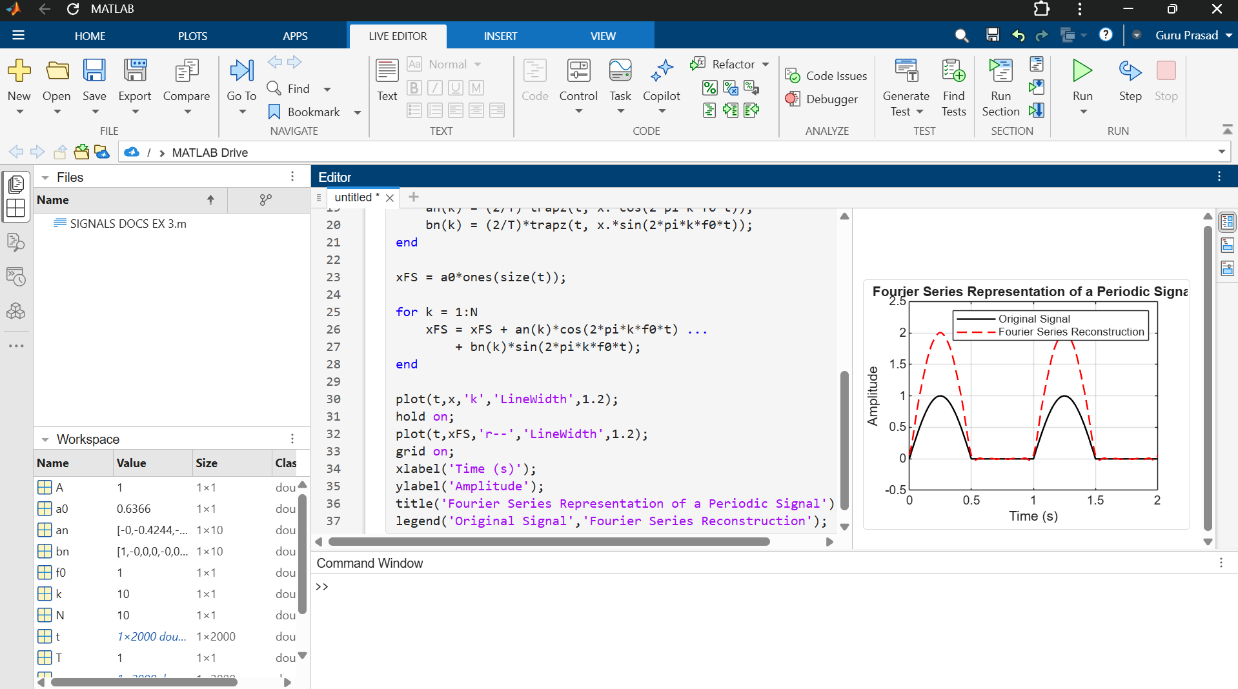

Objective 2: Determination of Fourier Coefficients and Harmonic Components
CODE :
clc; clear; close all;
figure;
f0 = 1;
T = 1/f0;
t = linspace(0,T,2000);
x = max(sin(2*pi*f0*t),0);
N = 10;
a0 = (2/T)*trapz(t,x);
an = zeros(1,N);
bn = zeros(1,N);
for k = 1:N
an(k) = (2/T)*trapz(t,x.*cos(2*pi*k*f0*t));
bn(k) = (2/T)*trapz(t,x.*sin(2*pi*k*f0*t));
end
n = 1:N;
C = sqrt(an.^2 + bn.^2);
phase = atan2(-bn,an);
fprintf('DC coefficient a0/2 = %.4f\n',a0/2);
disp(table(n.',an.',bn.',C.',phase.', ...
'VariableNames',{'Harmonic','a_n','b_n','Magnitude','Phase'}));
stem(n,C,'filled');
grid on;
xlabel('Harmonic Number');
ylabel('Harmonic Magnitude');
title('Harmonic Components of Periodic Signal');

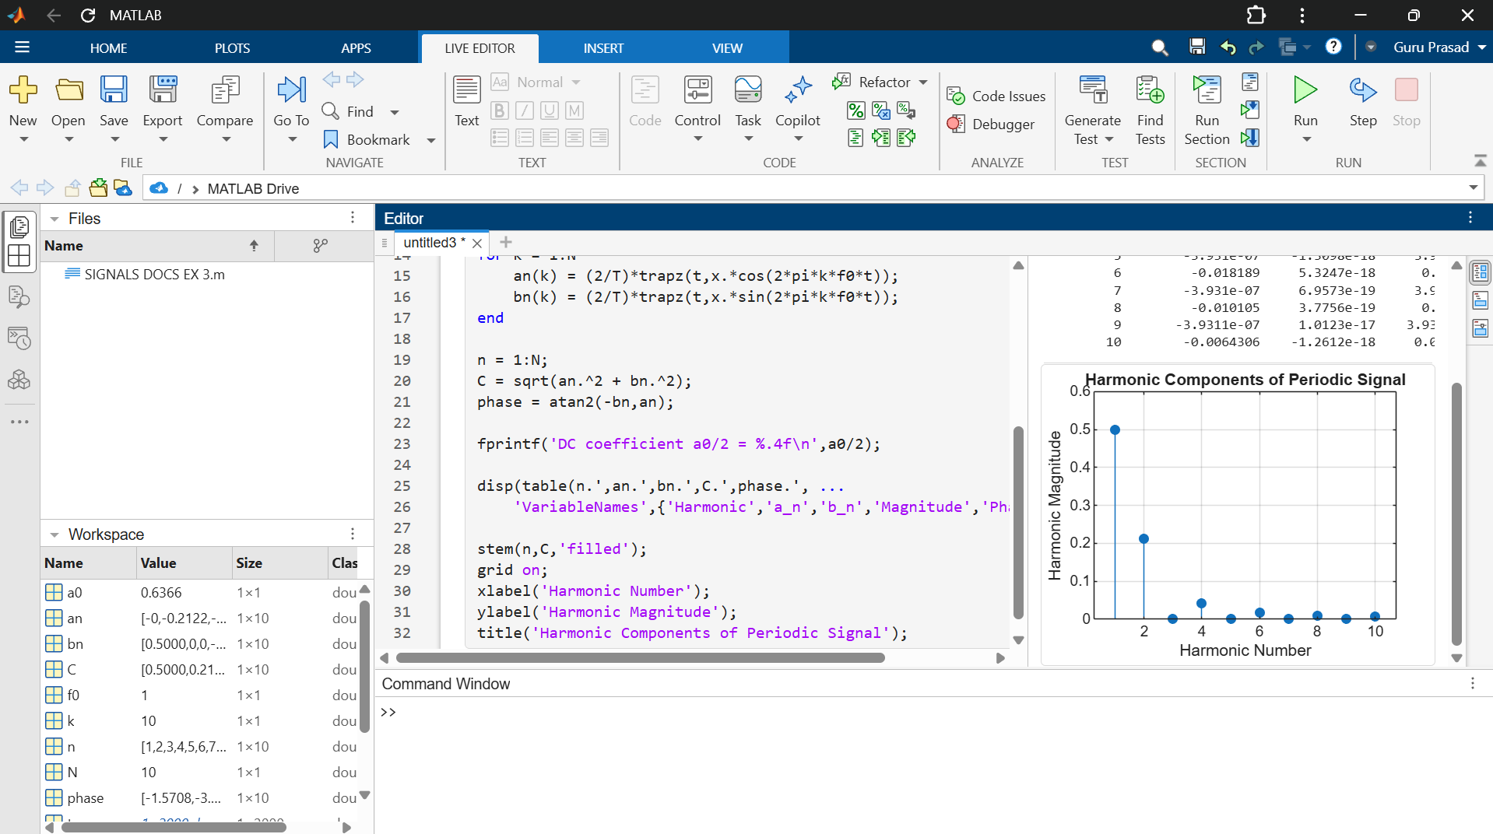

Objective 3: Analysis of Amplitude and Phase Spectra
CODE :
clc; clear; close all;
figure;
f0 = 1;
T = 1/f0;
t = linspace(0,T,2000);
x = max(sin(2*pi*f0*t),0);
N = 10;
a0 = (2/T)*trapz(t,x);
an = zeros(1,N);
bn = zeros(1,N);

for k = 1:N
an(k) = (2/T)*trapz(t,x.*cos(2*pi*k*f0*t));
bn(k) = (2/T)*trapz(t,x.*sin(2*pi*k*f0*t));
end
A = sqrt(an.^2 + bn.^2);
P = atan2(-bn,an);
n = 1:N;
subplot(2,1,1);
stem(n,A,'filled');
grid on;
xlabel('Harmonic Number');
ylabel('Amplitude');
title('Amplitude Spectrum');
subplot(2,1,2);
stem(n,P,'filled');
grid on;
xlabel('Harmonic Number');
ylabel('Phase (rad)');
title('Phase Spectrum');

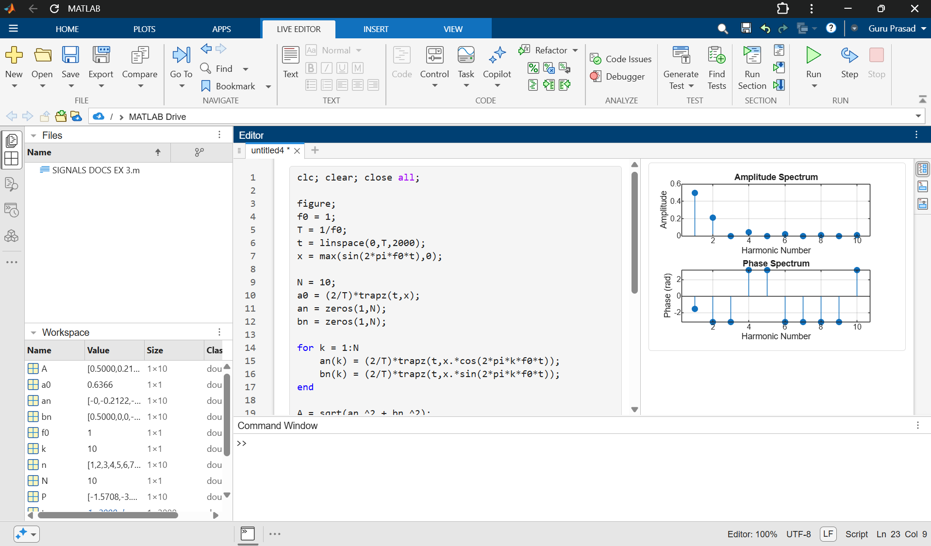

Objective 4: Verification of Fourier Series Reconstruction and Signal Characteristics
CODE :

clc; clear; close all;
figure;
f0 = 1;
T = 1/f0;
t = linspace(0,2*T,4000);
x = max(sin(2*pi*f0*t),0);
N = 10;
a0 = (2/T)*trapz(t(1:2000),x(1:2000));
an = zeros(1,N);
bn = zeros(1,N);
tt = t(1:2000);
xx = x(1:2000);
for k = 1:N
an(k) = (2/T)*trapz(tt,xx.*cos(2*pi*k*f0*tt));
bn(k) = (2/T)*trapz(tt,xx.*sin(2*pi*k*f0*tt));
end
xr = a0/2*ones(size(t));
for k = 1:N
xr = xr + an(k)*cos(2*pi*k*f0*t) ...
+ bn(k)*sin(2*pi*k*f0*t);
end
err = x-xr;
subplot(2,1,1);
plot(t,x,'k',t,xr,'r--','LineWidth',1.1);
grid on;
xlabel('Time (s)');
ylabel('Amplitude');
title('Original and Reconstructed Signals');
legend('Original','Reconstructed');
subplot(2,1,2);
plot(t,err,'b');
grid on;
xlabel('Time (s)');
ylabel('Error');
title('Reconstruction Error');
